**Q:3** Generate a model for an insurance company to hold information on the insurer's vehicle, and create a chart of monthly, yearly, and quterly premiums based on no. of years of insurance where in each year, the value of the vehicle depreciates by 7%.

**Solution:** Insurance Model with Depreciation and Premium Calculation

Here’s a Python model that holds information about an insurer’s vehicle and calculates monthly, quarterly, and yearly premiums based on the vehicle's depreciation over the years.

**Code:**

|  |
| --- |
| import matplotlib.pyplot as plt    class VehicleInsurance:  def __init__(self, owner_name, vehicle_value, insurance_years, annual_premium_rate):  self.owner_name = owner_name  self.initial_value = vehicle_value  self.current_value = vehicle_value  self.insurance_years = insurance_years  self.annual_premium_rate = annual_premium_rate  self.premiums = {}    def calculate_depreciation(self):  for year in range(1, self.insurance_years + 1):  depreciation = self.current_value * 0.07 # 7% depreciation each year  self.current_value -= depreciation  annual_premium = self.current_value * self.annual_premium_rate / 100  monthly_premium = annual_premium / 12  quarterly_premium = annual_premium / 4  self.premiums[year] = {  "Annual": annual_premium,  "Quarterly": quarterly_premium,  "Monthly": monthly_premium  }    def display_premiums(self):  print(f"Premiums for {self.owner_name}'s vehicle:")  for year, premium in self.premiums.items():  print(f"Year {year}: Annual: {premium['Annual']:.2f}, Quarterly: {premium['Quarterly']:.2f}, Monthly: {premium['Monthly']:.2f}")    def plot_premiums(self):  years = list(self.premiums.keys())  annual_premiums = [self.premiums[year]['Annual'] for year in years]  quarterly_premiums = [self.premiums[year]['Quarterly'] for year in years]  monthly_premiums = [self.premiums[year]['Monthly'] for year in years]    plt.plot(years, annual_premiums, label='Annual Premium')  plt.plot(years, quarterly_premiums, label='Quarterly Premium', linestyle='--')  plt.plot(years, monthly_premiums, label='Monthly Premium', linestyle=':')  plt.xlabel('Years')  plt.ylabel('Premium Amount')  plt.title('Vehicle Insurance Premium Over Time')  plt.legend()  plt.show()    # Example usage  vehicle_insurance = VehicleInsurance(owner_name="John Doe", vehicle_value=500000, insurance_years=5, annual_premium_rate=5)  vehicle_insurance.calculate_depreciation()  vehicle_insurance.display_premiums()  vehicle_insurance.plot_premiums() |

**Output:**

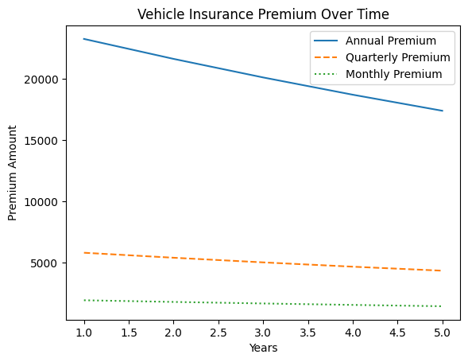

**Q:4** Generate a model to represent interest calculations of a Bank account where the process of calculating interest for 6 months is a. Find minimum balance for each month b. Make a total of all minimum balances c. Calculate interest based on interest rate d. Divide interest by 12 to find one-month interest e. Multiply interest by 6 to show interest in the account. Generate a model to represent transactions and interest calculations for 6 months.

**Solution:** Bank Interest Calculation Model

Here’s a Python model to represent a bank account with interest calculations based on minimum balances over six months.

**Code:**

|  |
| --- |
| import random    class BankAccount:  def __init__(self, account_holder, interest_rate):  self.account_holder = account_holder  self.interest_rate = interest_rate  self.transactions = {month: [] for month in range(1, 7)}  self.minimum_balances = []    def add_transaction(self, month, amount):  self.transactions[month].append(amount)    def calculate_minimum_balances(self):  for month, trans in self.transactions.items():  balance = sum(trans)  if balance:  self.minimum_balances.append(min(trans))  else:  self.minimum_balances.append(0)    def calculate_interest(self):  total_min_balance = sum(self.minimum_balances)  interest_per_year = (total_min_balance * self.interest_rate) / 100  monthly_interest = interest_per_year / 12  six_month_interest = monthly_interest * 6  return six_month_interest    def display_account(self):  print(f"Account Holder: {self.account_holder}")  print(f"Minimum Balances for 6 months: {self.minimum_balances}")  print(f"Interest earned over 6 months: {self.calculate_interest():.2f}")    # Example usage  bank_account = BankAccount(account_holder="Alice", interest_rate=3.5)    # Random transactions for 6 months  random.seed(42)  for month in range(1, 7):  for _ in range(random.randint(1, 5)):  bank_account.add_transaction(month, random.randint(1000, 10000))    bank_account.calculate_minimum_balances()  bank_account.display_account() |

**Output:**

